Tectonic significance of the Buldya Group, Western Australia
AB Lastname^{1*} and EF Lastname² [Arial 10 pt]
* corresponding author: [name]@uwa.edu.au
- Centre for Exploration Targeting (CET), The University of Western Australia, Crawley WA 6009
- Geological Survey of Western Australia, 100 Plain Street, East Perth WA 6051, Western Australia
The Buldya Group contains, in ascending order, the Townsend Quartzite and the Lefroy, Browne, Hussar, Kanpa, and Steptoe Formations. The Lefroy and Browne Formations are probably lateral equivalents. The Ilma Formation and Mason Conglomerate are included also, although their stratigraphic level within the group is uncertain. The group comprises siltstone, mudstone, sandstone (in part quartzite), dolomite (commonly stromatolitic), and halite and other evaporite minerals. In core, rocks of the group are commonly chocolate brown or light ferrous green, with pink and red-tinted evaporites. Evaporites have been intersected in drillholes, but are not known in outcrop. Halotectonics, due to thick evaporites in the lower Browne Formation, appear to be a major structural control, if not the dominant control, in the Officer Basin (Simeonova and Iasky, 2004). The Buldya Group is known from drillhole and seismic data, scattered isolated outcrops on COOPER, TALBOT, and BENTLEY 1:250 000 map sheets in the west Musgrave region, and WARRI, MADLEY, ROBERT, THROSSELL, and NEALE elsewhere across the southern Officer Basin. The most extensive outcrops are east of Lake Disappointment and in Constance Headland, where major cauliflower-like structures visible on satellite imagery suggest large scale salt expulsion. The group underlies Phanerozoic rocks or Cenozoic cover throughout much of the southwestern Officer Basin, and was intersected in a series of petroleum and stratigraphic drillholes (Perincek, 1998) that include: Browne 1 and 2, Dragoon 1, Hussar 1, Kanpa 1A, Lungkarta 1, Yowalga 2 and 3; Bureau of Mineral Resources (BMR, now Geoscience Australia (GA)) drillholes Madley 1, Talbot 1, 3, and 4, Throssell 1, and Warri 20. (260 words)

Reference(s)
Author, AB, Second, CD and Third, EF 2012, Title…: Journal or periodical, v. #, p. #–#.

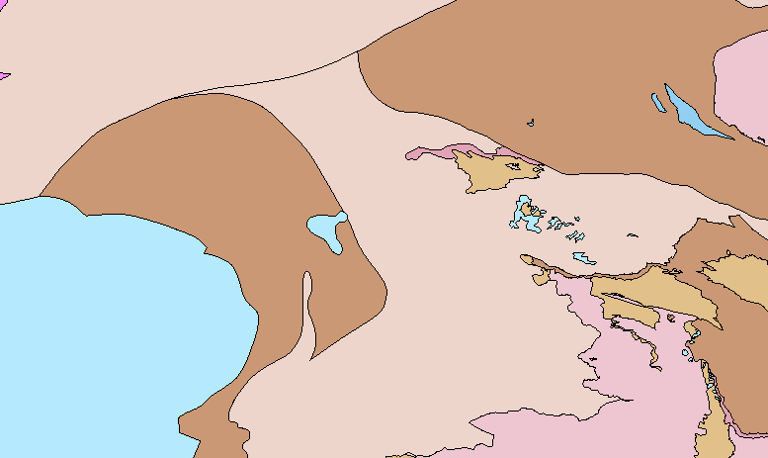
Figure 1. Extent of Amadeus Basin on northern margin of the Arunta Orogen

